1. **Acute Lymphocytic Leukemia (ALL):**
   * **A fast-growing leukemia that affects lymphocytes (a type of white blood cell).**
   * **Common in children but can occur in adults.**
   * **Symptoms include fatigue, fever, and easy bruising.**

**Subtypes of ALL:**

* **Early pre-B ALL:** This subtype is characterized by the presence of early B-cell markers.
* **Common ALL:** The most frequent subtype, it affects both children and adults.
* **Pre-B ALL:** Involves slightly more mature B cells.
* **Mature B-cell ALL:** A subtype with more mature B cells.
* **T-cell ALL:** Originates from T lymphocytes

1. **Acute Myeloid Leukemia (AML):**
   * **A rapidly progressing leukemia that affects myeloid cells.**
   * **Common in older adults.**
   * **Symptoms include anemia, infections, and bleeding.**

**Acute Myeloid Leukemia (AML) encompasses several notable subsets. Let’s explore them:**

1. **Acute Promyelocytic Leukemia (APL):**
   * **APL is characterized by a specific genetic abnormality (PML-RARA fusion).**
   * **It often presents with bleeding tendencies and responds well to targeted therapy with all-trans retinoic acid (ATRA) and arsenic trioxide.**
2. **Core-Binding Factor AML (CBF-AML):**
   * **CBF-AML includes AML cases with specific genetic alterations, such as t(8;21) or inv(16).**
   * **These alterations affect core-binding transcription factors and have distinct clinical features.**
3. **AML in Younger Patients Fit for Intensive Chemotherapy:**
   * **This subset includes patients who can tolerate aggressive chemotherapy regimens.**
   * **Treatment aims to achieve complete remission.**
4. **AML in Older/Unfit Patients (Usually at the Age Cutoff of 60-70 Years):**
   * **Older or medically compromised patients may receive less intensive treatment.**
   * **Therapeutic decisions consider comorbidities and overall health.**
5. **Chronic Lymphocytic Leukemia (CLL):**
   * **A slow-growing leukemia that affects B lymphocytes.**
   * **Common in older adults.**
   * **Often asymptomatic initially.**

**Let’s explore the subsets of Chronic Lymphocytic Leukemia (CLL):**

1. **Rai Staging System:**
   * **CLL is often staged using the Rai system, which classifies patients into five stages (0 to IV).**
   * **Staging is based on the number of lymphocytes, red blood cells, and platelets in the blood.**
   * **Early-stage CLL (Stage 0) may not require immediate treatment, while advanced stages (III and IV) may necessitate intervention.**
2. **ZAP-70 and CD38 Expression:**
   * **These markers help predict disease progression.**
   * **Patients with high ZAP-70 or CD38 expression tend to have a more aggressive course.**
3. **IGHV Mutation Status:**
   * **CLL can be categorized based on whether the immunoglobulin heavy chain variable region (IGHV) gene is mutated or unmutated.**
   * **Patients with mutated IGHV tend to have a more indolent disease course, while unmutated IGHV is associated with a worse prognosis.**
4. **Del(17p) and TP53 Mutation:**
   * **Patients with deletion of chromosome 17p (del(17p)) or TP53 mutation have poor outcomes.**
   * **These genetic abnormalities impact treatment response.**
5. **Chronic Myeloid Leukemia (CML):**
   * **A slowly progressing leukemia that affects myeloid cells.**
   * **Often detected during routine blood tests.**
   * **May cause fatigue and abdominal discomfort.**

 Let’s explore the subsets of **Chronic Myeloid Leukemia (CML)**:

1. **Chronic Phase (CP):**
   * This is the initial phase of CML.
   * Patients are often asymptomatic or experience mild symptoms.
   * Treatment aims to control the disease and prevent progression.
2. **Accelerated Phase (AP):**
   * In this phase, CML becomes more aggressive.
   * Patients may have increased blast cells in the blood or bone marrow.
   * Treatment intensification is necessary.
3. **Blast Crisis Phase:**
   * The most advanced stage of CML.
   * Blast cells (immature cells) proliferate rapidly.
   * Urgent treatment, such as chemotherapy or stem cell transplantation, is required.

**L** **Leukemia has different stages depending on the type. Let’s break it down:**

1. **Acute Lymphocytic Leukemia (ALL):**
   * **ALL doesn’t follow the typical numbered staging system because it originates in the bone marrow and doesn’t form tumor masses.**
   * **Instead, physicians consider factors like the subtype of ALL and the patient’s age.**
   * **Subtypes include:**
     + **Early pre-B ALL**
     + **Common ALL**
     + **Pre-B ALL**
     + **Mature B-cell ALL**
     + [**T-cell ALL1**](https://www.cancercenter.com/cancer-types/leukemia/stages)[**2**](https://www.medicalnewstoday.com/articles/stages-of-leukemia)**.**
2. **Acute Myeloid Leukemia (AML):**
   * **Like ALL, AML doesn’t have a standard staging system.**
   * **Physicians focus on other factors to differentiate stages.**
   * [**Cytologic tests and lab tests help identify the subtype of AML1**](https://www.cancercenter.com/cancer-types/leukemia/stages)**.**
3. **Chronic Lymphocytic Leukemia (CLL):**
   * **CLL is typically staged using the Rai system, which has five stages (0 to IV).**
   * [**Staging is based on the number of lymphocytes, red blood cells, and platelets in the blood3**](https://www.nm.org/conditions-and-care-areas/cancer-care/leukemia-cancer-care/leukemia/stages)**.**
4. **Chronic Myeloid Leukemia (CML):**
   * **CML has three phases:**
     + **Chronic phase**
     + **Accelerated phase**
     + [**Blast crisis phase**](https://www.cancercenter.com/cancer-types/leukemia/stages)[**1**](https://www.cancercenter.com/cancer-types/leukemia/stages)**.**

**link :** [**Blood Cells Cancer (ALL) dataset (kaggle.com)**](https://www.kaggle.com/datasets/mohammadamireshraghi/blood-cell-cancer-all-4class/data)

**Overview**

The Blood Cells Cancer (ALL) dataset is designed to help in the diagnosis of Acute Lymphoblastic Leukemia (ALL) using images of blood cells. This dataset is crucial because traditional diagnostic methods for ALL are invasive, costly, and time-consuming.

**Dataset Details**

* **Total Images**: 3242
* **Patients**: 89
* **Image Type**: Peripheral Blood Smear (PBS) images
* **Magnification**: 100x
* **Format**: JPG files
* **Classes**:
  + **Benign** (Non-cancerous)
  + **Malignant** (Cancerous) with three subtypes:
    - Early Pre-B
    - Pre-B
    - Pro-B

**Malignant Categories Explained**

The term "malignant" refers to cancerous cells. In this dataset, the malignant cells are divided into three subtypes:

1. **Pre-B**:
   * **Description**: This is a specific stage in the development of B-cell lymphocytes (a type of white blood cell) where the cells are cancerous.
   * **Number of Images**: There are 955 images of Pre-B malignant cells in the dataset.
2. **Pro-B**:
   * **Description**: This is an earlier stage in the development of B-cell lymphocytes where the cells are cancerous.
   * **Number of Images**: There are 796 images of Pro-B malignant cells in the dataset.
3. **Early Pre-B**:
   * **Description**: This refers to an even earlier stage of cancerous B-cell development before the Pre-B stage.
   * **Number of Images**: Although it is a known subtype, the specific count of images for Early Pre-B is not explicitly mentioned in the provided information.

**Dataset Preparation**

The images were prepared and stained by skilled laboratory staff at the bone marrow laboratory of Taleqani Hospital in Tehran, Iran. These images were captured using a Zeiss camera attached to a microscope.

**Classes and Subtypes**

1. **Benign**:
   * Contains 512 images of non-cancerous blood cells.
2. **Malignant**:
   * **Pre-B**: Contains 955 images.
   * **Pro-B**: Contains 796 images.
   * **Early Pre-B**: This subtype is implied but not explicitly mentioned in the file counts provided.

**Usage**

* **Initial Screening**: The dataset can be used for the initial screening to distinguish between cancerous and non-cancerous cases.
* **Computer Vision Models**: It is suitable for training models to classify different subtypes of ALL.

**Licensing**

* **License**: Attribution-Non-commercial 4.0 International (CC BY-NC 4.0)

**Expected Update Frequency**

* **Not specified**

**Source Code**

For more technical details or to see an application of this dataset, you can refer to the [source code on GitHub](https://github.com/MAmirEshraghi/Lightweight-Deep-CNN-Based-Mobile-App-in-the-Screening-of-ALL).

**Directory Structure**

1. **Benign**: 512 files
2. **Malignant**:
   * **Pre-B**: 955 files
   * **Pro-B**: 796 files

**Summary**

This dataset is a valuable resource for researchers and developers working on automated systems for ALL detection. By training machine learning models on this dataset, we can improve the accuracy and efficiency of ALL diagnosis, making it less reliant on invasive and costly procedures.

**Abstract**

Background: B-cell acute lymphoblastic leukemia (B-ALL) is one of the most widespread cancers, and its definitive diagnosis demands invasive and costly diagnostic tests with side effects for patients. Access to definitive diagnostic equipment for B-ALL is limited in many geographical areas. Blood microscopic examination has always been a major B-ALL screening and diagnosis technique. Still, the examination of blood microscopically by laboratory personnel and hematologists is riddled with disadvantages. Meanwhile, AI techniques can achieve remarkable results in blood microscopy image analysis. The present study aimed to design and implement a well-tuned based on deep CNN to detect B-ALL cases from hematogones and then determine the B-ALL subtype.

Methods: Based on the well-designed and tuned model, a mobile application was also designed for screening B-ALL from non-B-ALL cases. In the modeling stage, a unique segmentation technique was used for color thresholding in the color LAB space. By applying the K-means clustering algorithm, and adding a mask to the clustered images, a segmented image was obtained to eliminate unnecessary components. After comparing the efficiency of three notable architectures of lightweight CNN (EfficientNetB0, MobileNetV2, and NASNet Mobile), the most efficient model was selected, and the proposed model was accordingly configured and tuned.

Results: The proposed model achieved an accuracy of 100%. Finally, a mobile application was designed based on this state-of-the-art model. In the real laboratory setting, the mobile application based on the proposed model classified B-ALL cases from other classes and achieved a sensitivity and specificity of 100% as a robust screening tool.

Conclusions: The application that relies on preprocessing and DL algorithms can be used as a powerful screening tool by hematologists and clinical specialists to ignore or minimize unnecessary bone marrow biopsy cases and decrease the B-ALL diagnosis time.

* **Proposed framework:** [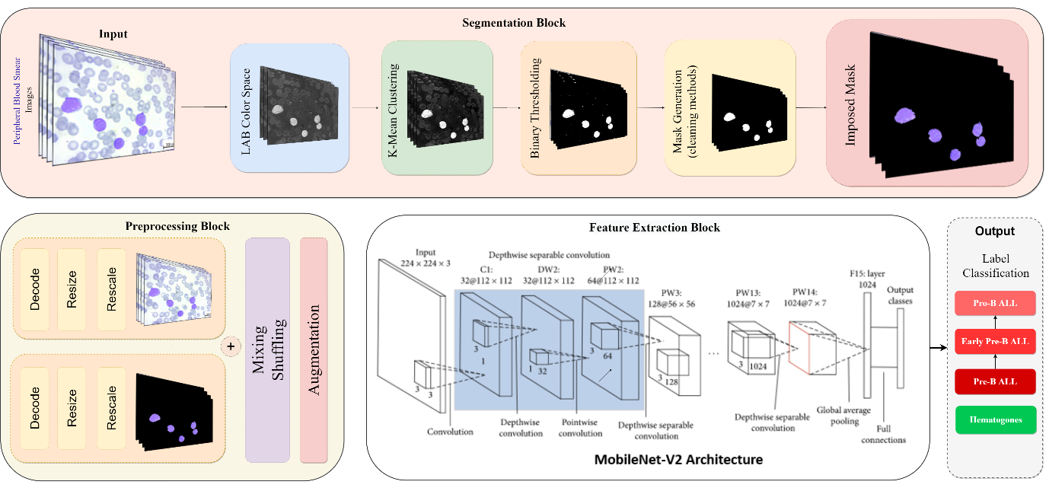](https://user-images.githubusercontent.com/92205834/160648346-cd4f23ff-513c-4b2d-b070-17affd5ea8ca.png)
* dataset samples:

[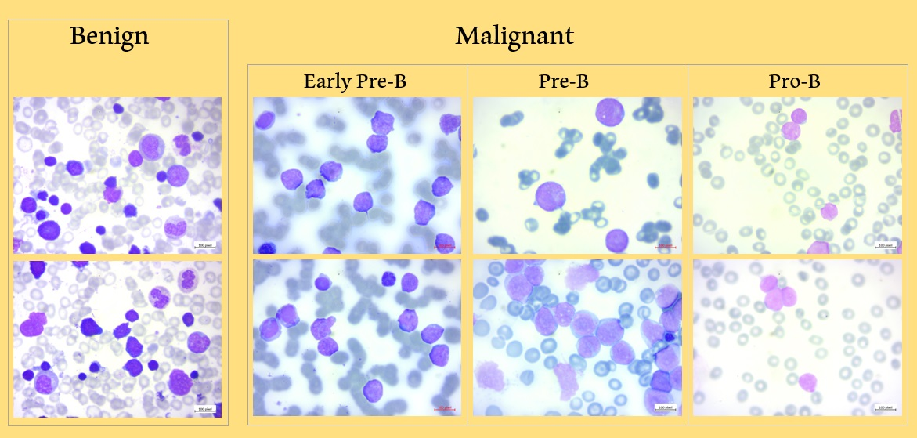](https://private-user-images.githubusercontent.com/92205834/238172742-7a98cd2c-0648-40ec-a92a-c84c1bbb95a2.jpg?jwt=eyJhbGciOiJIUzI1NiIsInR5cCI6IkpXVCJ9..mHPBLyESXqmDlxwG80XW-XoXV6eUuobT3Dj-xZeizYw)

* **Splitting data:**

[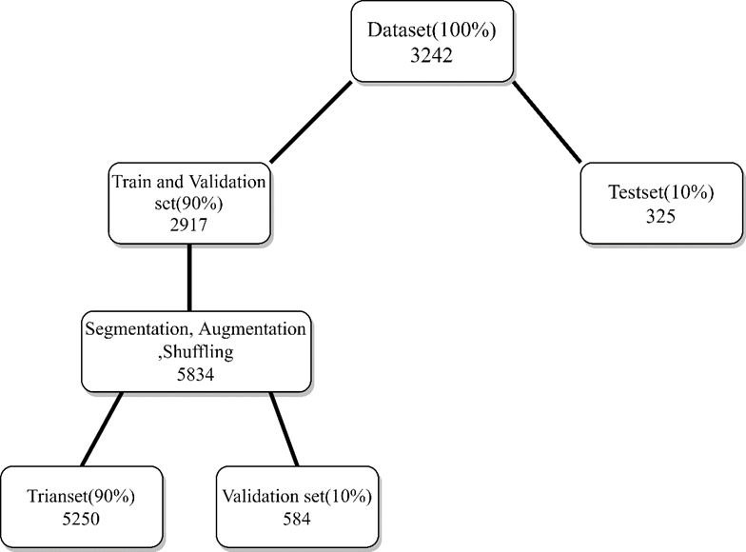](https://user-images.githubusercontent.com/92205834/160360088-21689fc7-0092-47c0-8828-f4940517c9a0.png)

* **Segmentation stages:**

[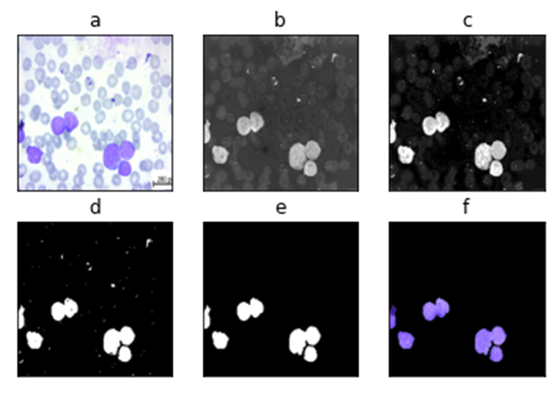](https://user-images.githubusercontent.com/92205834/160360181-881888b8-34a5-4fd4-b3e9-cebaa05bd58e.png)

a) RGB color space, b) LAB color space, c) K-Means Clustering d) Binary Thresholding, e) Cleaning methods and mask generation, f) Mask application on the RGB original image.

* **Performance of selected network in unique situation:**

[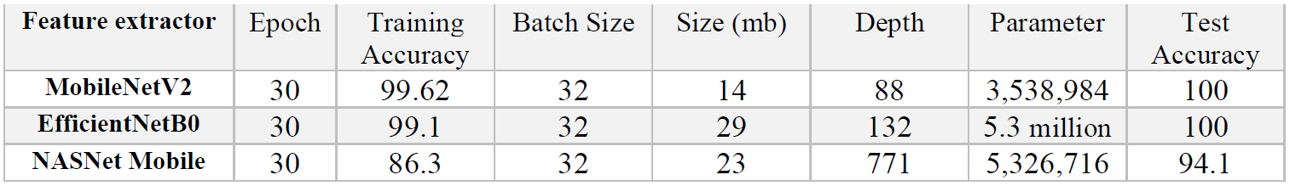](https://user-images.githubusercontent.com/92205834/160406634-c83943a3-250a-4402-bd27-b51e8b90b18e.png)

* **Results of detection Model (MobileNetV3):**

[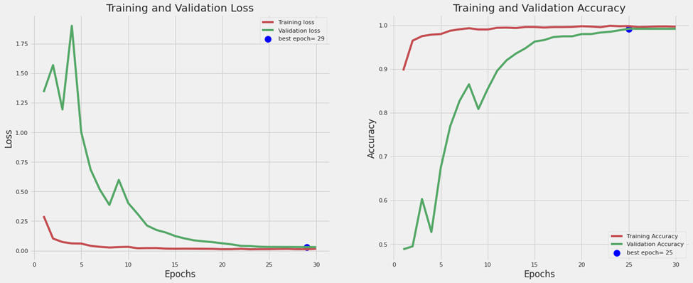](https://user-images.githubusercontent.com/92205834/160360330-581c268b-dd5d-458a-9722-e5e9557119fa.png) [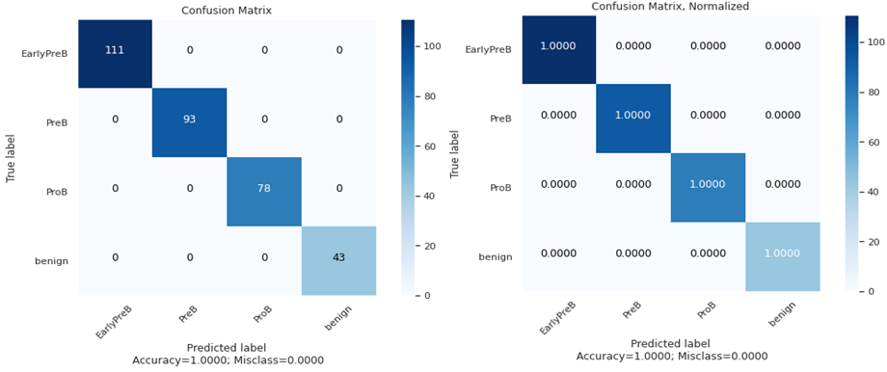](https://user-images.githubusercontent.com/92205834/160360345-7132cdcb-3754-4f0d-ac3c-665815f17131.png) [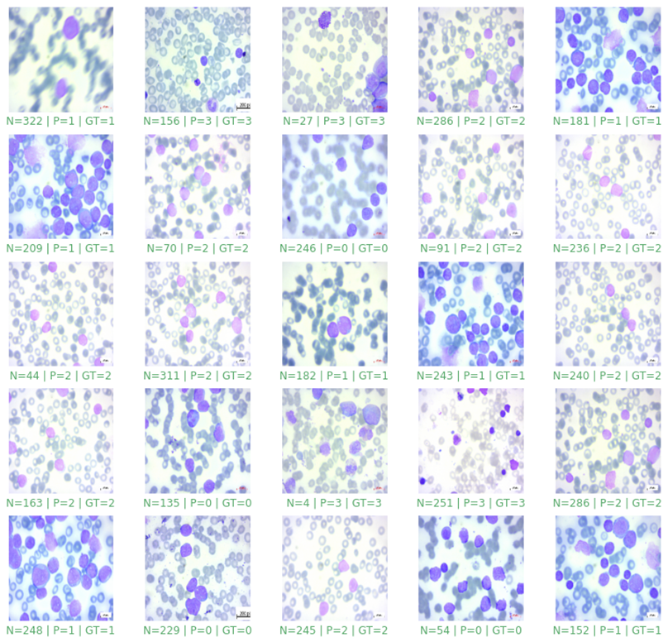](https://user-images.githubusercontent.com/92205834/160360362-45b4d4ac-1f2a-4e94-a8e7-fea75c3d531d.png)

* **Mobile Application Based on Proposed model in Detection and Diagnosis ALL:**

[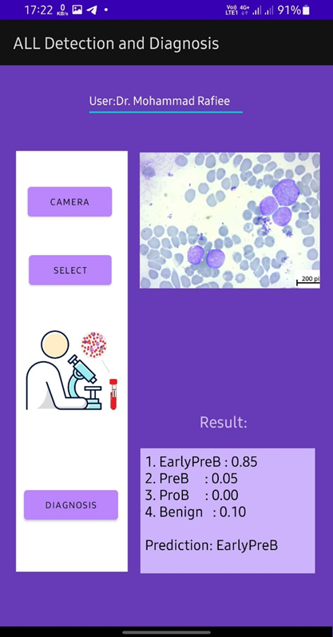](https://user-images.githubusercontent.com/92205834/160360502-9dd72bcf-30f1-489a-a67b-29a1fdd05fa1.png)

* **Datasets:**

ALL Dataset is available at: <https://www.kaggle.com/datasets/mohammadamireshraghi/blood-cell-cancer-all-4class>.

* **Citation:**

You may also access the paper: <https://doi.org/10.1016/j.imu.2023.101244>

Mustafa Ghaderzadeh, Mohammad Amir Eshraghi, Azamossadat Hossein, Mohammad Rafiee, Mohammad Hossein Moh